Upgrading Tally for new MVAT Rates of 6% & 13.5 % in Release 4.93
As everybody is aware of Vat Rate is changed in Maharashtra from 5.5% to 6% & 12.5% to 13.5% as on 17.09.2016 onwards here are the quick steps to update your tally with the above feature

- Paste the below link to your Browser:
Link
http://www.tallysolutions.com/website/html/downloads/tallyerp9-archive.php#section13

- Below page gets open , click there and download the stat file;
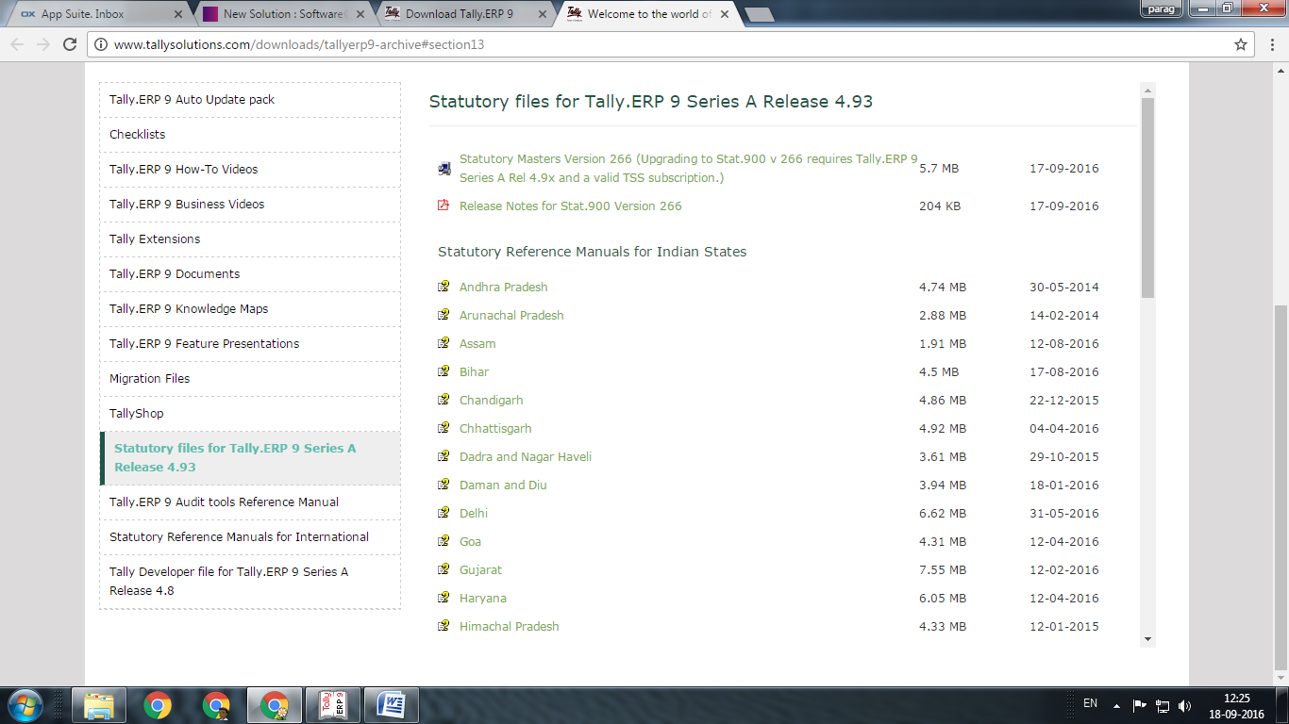
Click

- Once stat file get downloaded extract the same and paste to Tally application folder, procedure is as follow ;

- Right Click on Tally and go to Properties

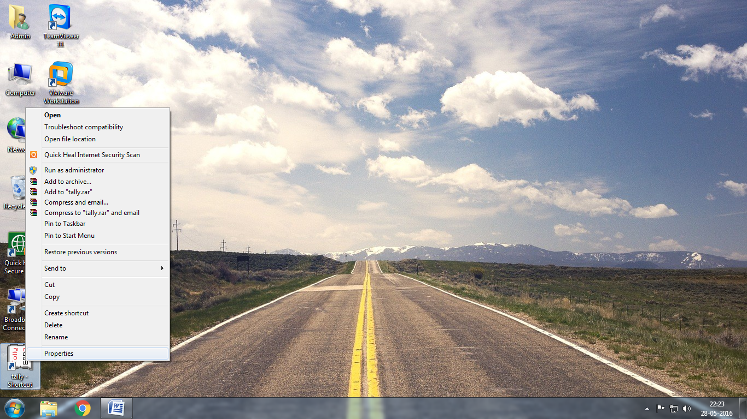

- Click on Open File Location or Find Target as Available
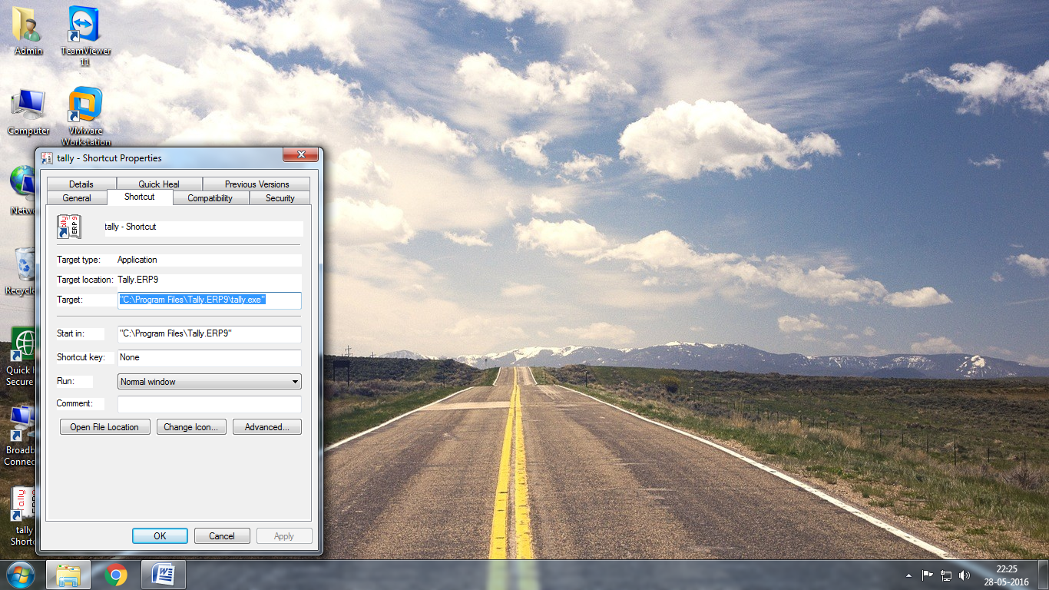

- Paste the Stat File Downloaded by you and allow to replace the old one and restart the tally
